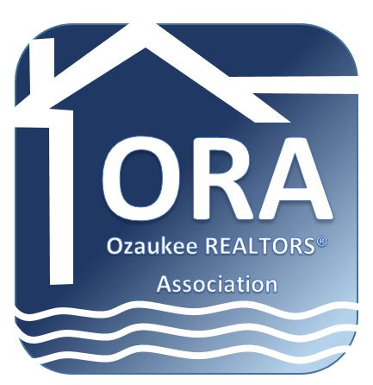

NEWS RELEASE

For Immediate Release
May 9, 2016

For More Information:
Call Tina Dorward
262-375-4730

Ozaukee REALTORS® Association Members Help at Habitat Rummage Sale

Cedarburg, WI—As part of its initiative to help the communities in Ozaukee County, Ozaukee REALTORS® Association had members help with the Habitat for Humanity Rummage Sale recently.

Habitat’s rummage sale included new and used items such as power tools, hardware, nails and other such items that it has received as donations and use in their builds. Proceeds from the rummage sale will go toward the current homes being built in Grafton and Port Washington.

“It’s always great to give back to the community,” said Kathy Bucholz, one of the ORA Board of Directors who helped at the rummage. “People were curious about our t-shirts and it was nice to be able to explain how REALTORS® volunteer and support such great causes such as Habitat for Humanity.”
The Ozaukee REALTORS® Association is headquartered in Cedarburg, Wisconsin. The mission of the Ozaukee REALTORS® Association is to serve its members by promoting professional and ethical conduct, to foster a spirit of cooperation among its members, to provide services and programs that assist its members in the successful conduct of their business, and to help defend the rights of all people to own and transfer real property.
pic included. Pictured from l to r: Kathy Bucholz, Adam Poehlman, Marietta Ticali
REALTOR® is a registered collective membership mark which identifies real estate professionals who are members of the NATIONAL ASSOCIATION OF REALTORS® and subscribe to its strict Code of Ethics.

###

